**1. Introduction to Hibernate Architecture**

**• Theory:**

1. **Defination and purpose of Hibernate as an ORM (Object Relational Mapping) tool :-**

**Defination** **:** Hibernate is a java framework that simplifiles the development of java application to interact with the database .

**(ORM) :** open source lightweight

Non invasive (does not force programmer to extends implement class interface invented by “Gavin king” in 2001

1. **Comparison between Hibernate and JDBC:-**

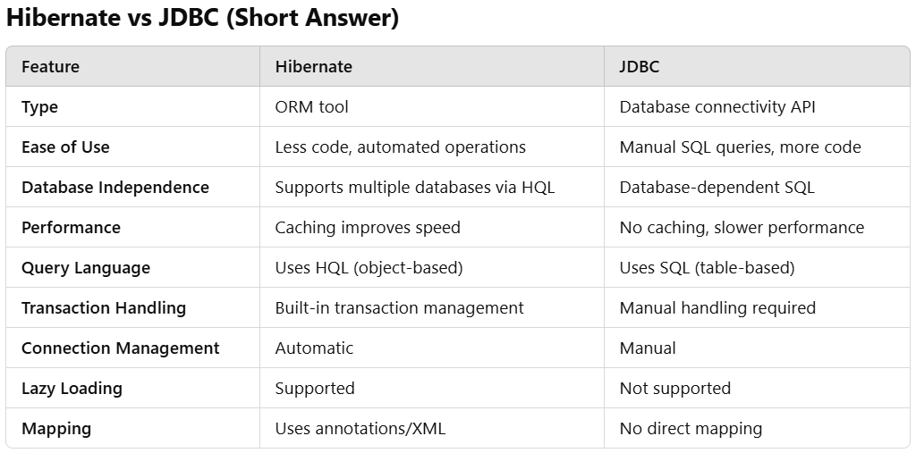

1. **Why use Hibernate? (Advantages: Database independence, automatic table creation, HQL, etc.):-**

Hibernate provides several advantages over traditional JDBC, making database interactions easier and more efficient.

**1. Database Independence**

* Hibernate supports multiple databases (MySQL, PostgreSQL, Oracle, etc.) without changing the code.
* Uses **HQL (Hibernate Query Language)** instead of database-specific SQL queries.

**2. Automatic Table Creation**

* Hibernate can automatically generate database tables from Java classes using **annotations or XML configurations**.
* No need to manually create tables in the database.

**4. HQL (Hibernate Query Language)**

* Unlike SQL, HQL works with Java **objects** instead of tables.
* More readable and portable across different databases.